Paper Review Process and Deadlines: July 21-August 20
SUBCOMMITTEE MEMBER RESPONSIBILITIES

ACTION ITEM #1: Accept Mira invitation and activate your account
DEADLINE: ASAP if you have not already done so

ACTION ITEM #1: Review assigned papers
DEADLINE: July 26-August 20
- Make sure you’ve activated the account created for you in Mira using the specific link in the Mira invite email.
- To view papers in Mira, select Reviewer Home to see your assigned papers.

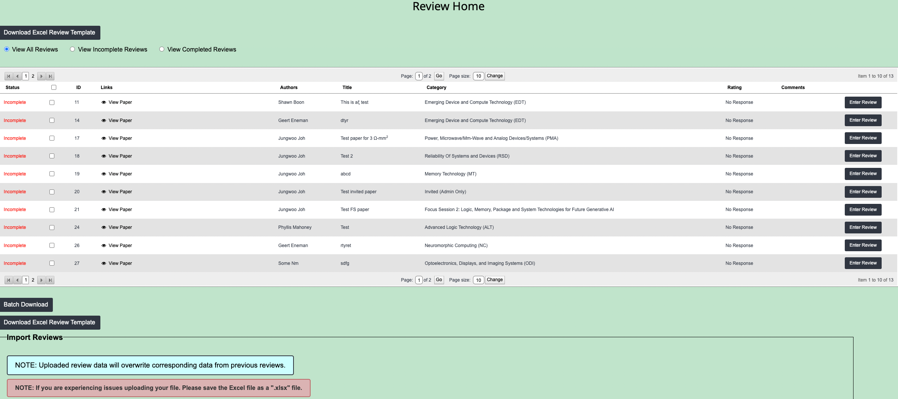

- You have one of two ways to enter a review:
  - Select Enter Review and complete the necessary fields
OR
  - Use the Excel Review Template. Important: row order must be maintained, therefore, spreadsheet cannot be sorted. You may filter results but need to maintain the order the papers listed.
- Once the review is submitted (or uploaded if using the spreadsheet), the status will change from Incomplete to Complete.
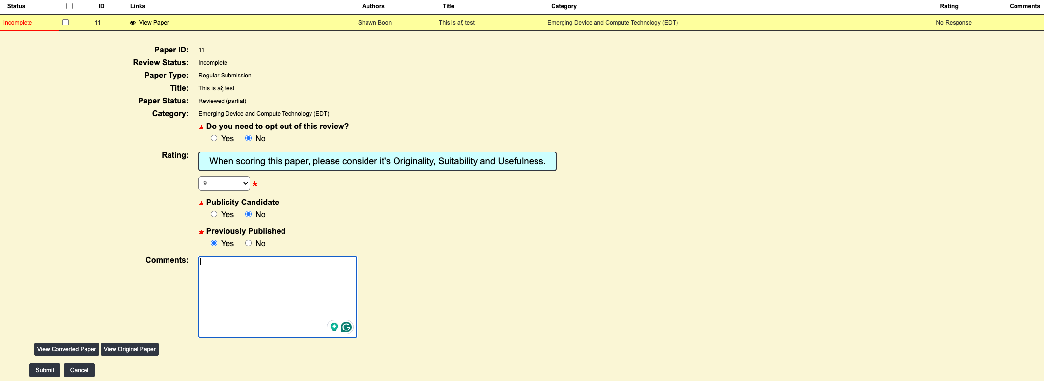

ABSTRACT RATING PROCEDURES

FINAL DISPOSITION OF ABSTRACTS
- Each abstract must either be accepted for inclusion in the IEDM program or it must be rejected. This determination should be made by the appropriate subcommittee using the rating procedures as aids in arriving at its collective judgement. It is critical that the Subcommittee Chairs determine the ownership (by a single subcommittee) of all papers prior to distributing these for rating by the SCMs.
- Final disposition (accept or reject) will be entered into Mira and reported to the Technical Program Chair at the Technical Program Meeting.

CRITERIA FOR INITIAL RATING
- Issues Related to Abstract Quality
  - Originality
  - Significance (interest, value)
  - Documentation (data, results, etc.)
  - Clarity (clearly states purpose of work and how much it advances the art - excessively long abstracts should be penalized in this category)
  - Accuracy (validity of data, interpretation, etc.)
  - Excessive use of arbitrary units [a.u.]

- Issues Not Related to Abstract Quality
  - Subject of abstract is outside the scope of the IEDM as described in the Call for Papers.
  - Give the abstract an "X" rating. This rating should rarely be used.
  - Reviewer is unable to knowledgeably or objectively rate paper due to:
    - Reviewer not sufficiently familiar with segment of field which the abstract addresses. Subcommittee member should seek the advice of an alternate reviewer within his/her organization.
    - In cases of Conflict of interest, give the paper a "C" rating.

ABSTRACTS PREVIOUSLY PRESENTED AT OTHER CONFERENCES
- General guidelines are that papers previously presented or published are not eligible for acceptance at IEDM.
- The following guideline will be applied for the IEDM with respect to paper acceptance of work presented at informal conferences with limited attendance. If such a submitted abstract has some definable added value in the judgement of the subcommittee it can be included in the IEDM technical program. Bring evidence of previously presented material to the August Meeting for review.
- Note: arxiv is not considered pre-publication on its own. However, if such a paper is accepted the session chairs should be instructed to follow up closely with the authors. If the paper is published or presented elsewhere prior to its presentation at IEDM it should be removed from the program.

RATING PROCEDURES FOR ABSTRACT QUALITY
A 10 point system of abstract ratings. All abstracts must be given an integer rating with no other qualifications (i.e., no + or - or fractional ratings). Note: in rating a paper, take into account the state of maturity of the technology being reported; this is especially important for topics in emerging areas for which technical details may be unresolved or not yet fully understood.

- Rating Criteria
  - 9 - 10 Innovative work of high interest which significantly advances the art; well documented with results; clear and descriptive text; is well conceived and results apparently accurate. Abstract must be included.
  - 7-8 Original work which significantly advances the art and is of interest and value; reasonably well documented with results and text, work is well conceived and apparently accurate. Abstract should be included in program.
  - 5 - 6 Original work which advances the art somewhat but is of questionable interest or value; reasonably well documented with results and text, and apparently accurate.
Or
Original work which significantly advances the art and is of questionable interest or value; reasonably well documented with results or is not clearly presented in text or is of questionable validity/accuracy. Abstract may be included in program depending on consensus of the subcommittee.
  - 3 - 4 Work is of questionable originality, interest or value; however, work is well documented and clear, and appears to be valid/accurate. Abstract should probably not be included in program.
  - 1 - 2 Work is not original, does not advance art, or is of no interest/value; work is poorly documented or quite vague, work is invalid or includes obvious errors or otherwise is of low quality. Abstract must not be included in program.

