ADM in MTL: Performance, COnstruction, learnings

IMSCS WHITE PAPER
Randy Osborne  IAGS XAR |  | “The most certain way to succeed is to always try more one time.”  – Thomas Edison

Executive Summary
MTL-P is the first product intercept of ADM, a new Intel made memory technology, and MTL is also the first time for 3D construction (die stacking) for high volume client across multiple SKUs. This paper describes the memory bandwidth problem, the evolution towards tightly coupled logic+memory, the realization of tightly coupled logic+memory in MTL, and the learnings from this effort.

The memory bandwidth problem & tightly coupled logic and memory
The performance of graphics and AI accelerators depends heavily on memory bandwidth. The challenge for memory architects is not only to increase the bandwidth but do so within a fixed power envelope to avoid diverting power from logic. Memory architects have been addressing this challenge for CPUs for decades with SRAM caches. Unfortunately, the re-use footprint for graphics and AI accelerators is often many times larger than is cost effective for a SRAM solution. Consequently, some products now add specialized DRAM memory on-package, such as HBM. However, HBM is expensive and has power scaling challenges.
A more scalable approach is to tightly couple logic with short, wide datapaths to high density memory. This direction requires three enablers:
- A workload with re-use footprint substantially residing in a reasonable size memory capacity. Graphics workloads have this characteristic as depicted by the following generalized cartoon of BW vs capacity. The capacity must be limited for both construction and power reasons – shorter wires means lower power.
- Technology for tight coupling. Foveros technology for 3D die stacking is ideal for this.
- High bandwidth, moderate capacity memory – needs to be more capacity than SRAM and more bandwidth or less cost than alternatives, like HBM. Intel’s ADM technology fits this bill. The following chart of power vs BW shows the memory power for ADM vs other options.
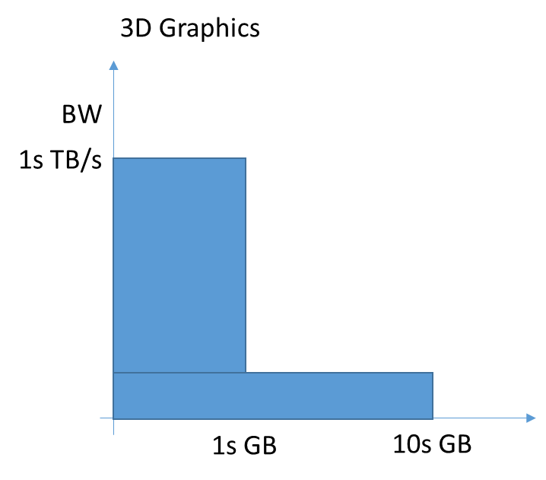
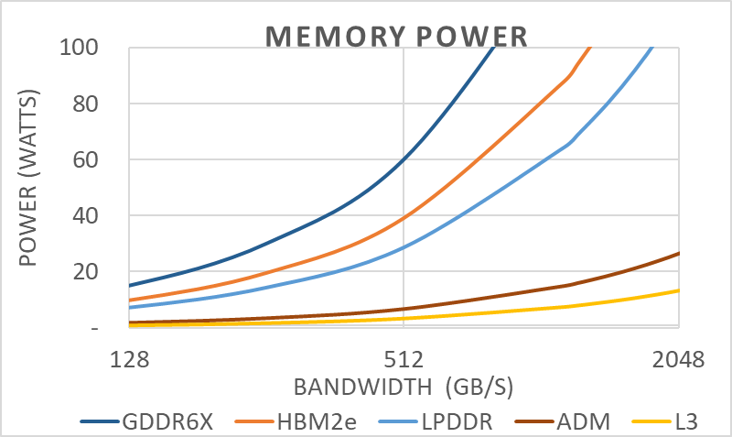
The memory hierarchy pyramid below shows tightly coupled memory as a new layer with SRAM-like tight coupling but with heterogenous manufacturing process permitting optimization for more capacity than SRAM.
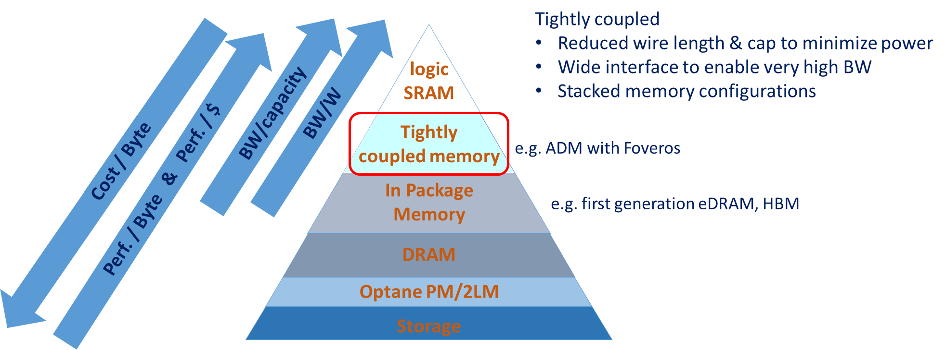

MTL
MTL is the first product intercept combining Foveros 3D construction with ADM to achieve tightly coupled logic and memory. The MTL product family is also the first use of die disaggregation and 3D construction for high volume client: all MTL product SKUs have some number of top die stacked on a base die. The following picture shows top view and cross section side view of the MTL-P-halo SKU, which has 4 top dies on top of an ADM base die. The other SKUs have a passive base die, but otherwise the 3D construction follows the same as shown in this picture. The 4 top dies are
- A core die (light blue) with 6 Redwood cove IA cores and 8 Atom cores
- A SoC die (pink) with interface to LPDDR memory, media engine, display engine, imaging, and many types of IOs
- A IOE (gray) die with additional high speed IOs (IOE= IO expander)
- A graphics die (dark blue) with 192 execution units (EUs)
The 4 top dies connect through die to die links (D2D) depicted by the turquoise boxes. These D2D links are implemented by the top level (global) metals in the base die that connect micro bumps on one top die to micro bumps on a neighboring top die. Power and IOs to/from the top die pass through silicon vias (TSVs) in the base die to reach C4 bumps on the bottom of the base die to connect to the package. The base die is face up, i.e. the active region of the base die faces the active region of the top dies.
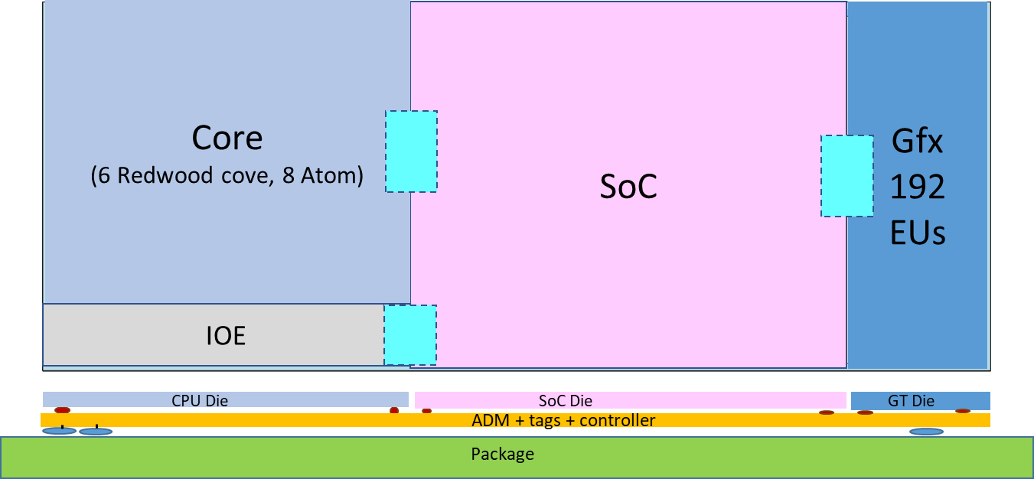
The base die is a memory side cache with topology shown in the following figure.
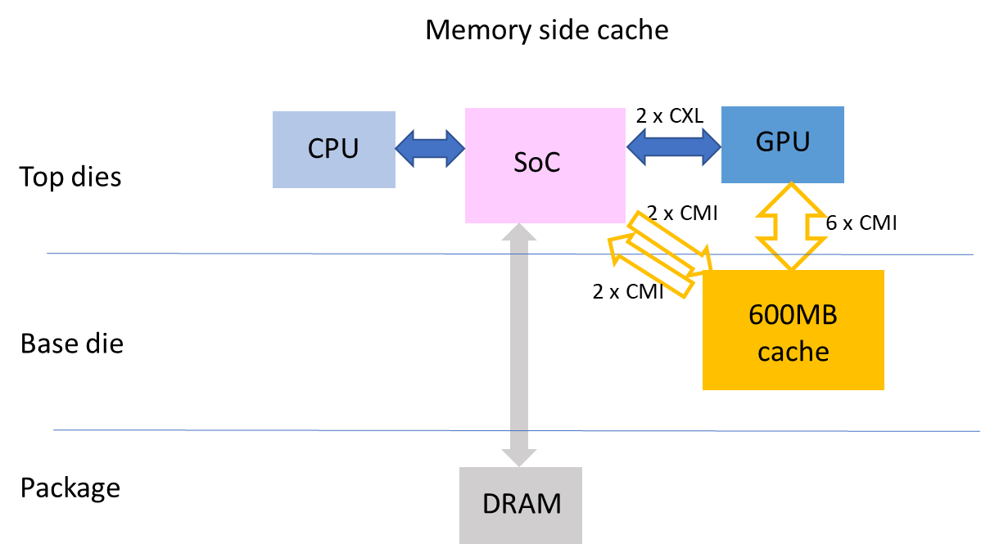
There are two regions of vertical connections, shown as yellow arrows in the above figure, between the top die and the cache logic in the base die. These vertical connections are called shafts.
With a capacity of 600MB and over 300GB/s the memory side cache in the ADM base die provides outstanding graphics performance -- up to 45% speedup, average of 20%, for 1GHz GT -- as shown in the following chart.
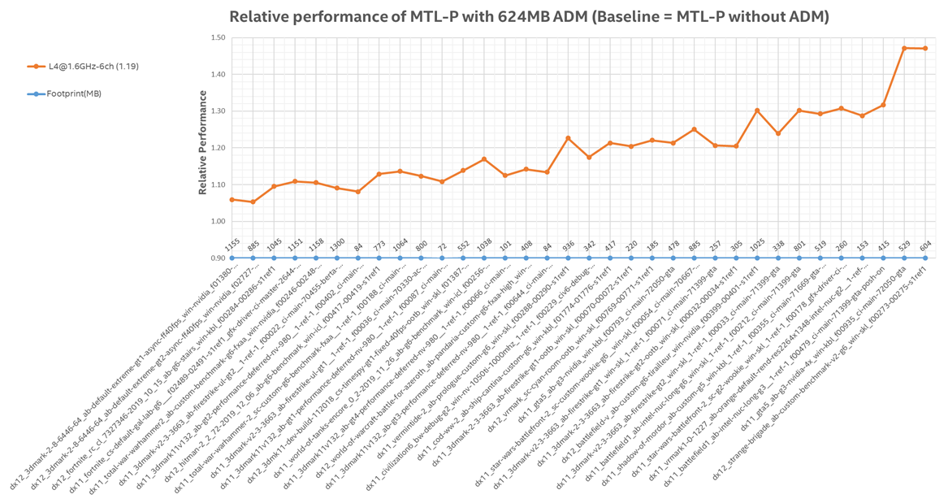

Further construction details
The three figures on the following page show a walk depicting
- The total outline of base die = shadow under all top die
- The area actually utilized by ADM datablocks. The larger rectangles are 1MB; the smaller rectangles are .5MB. The irregular pattern of datablocks and white regions devoid of datablocks are caused by various keep outs
- The keep outs: the pass through for the IOs at top and bottom, high density TSV regions for the DLVRs (orange bars), high density TSV regions for power gates (red stripes), SRAM blocks for the cache tags (purple)

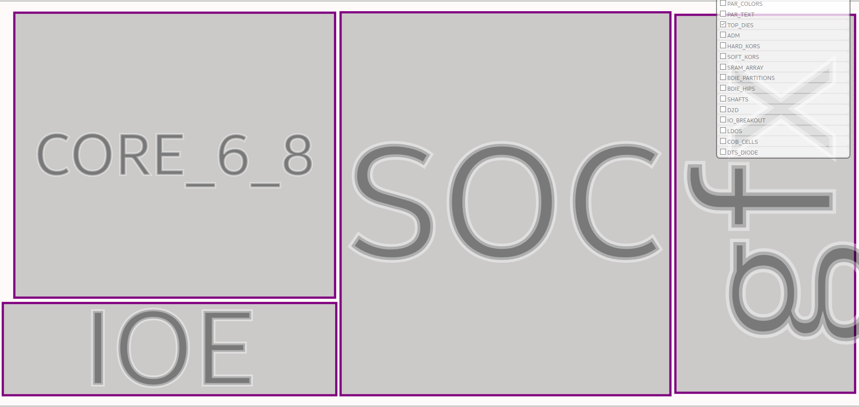
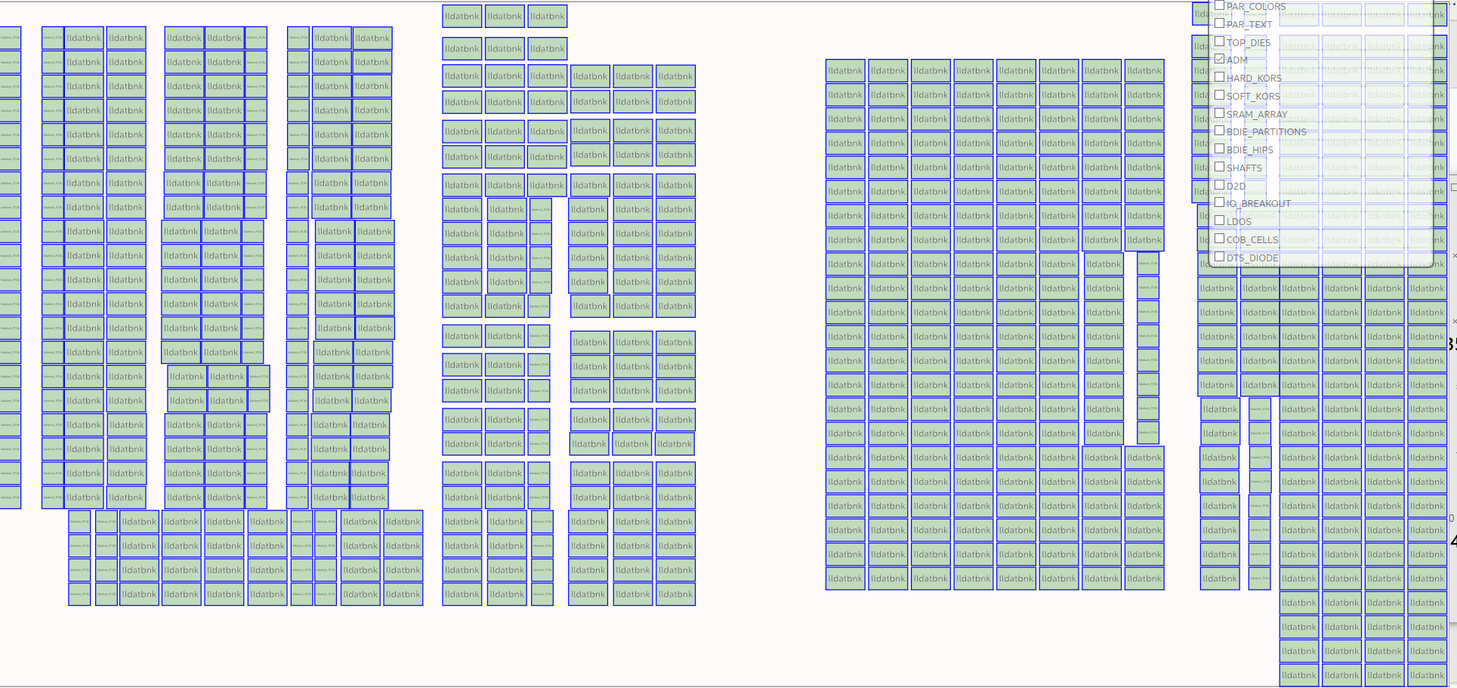
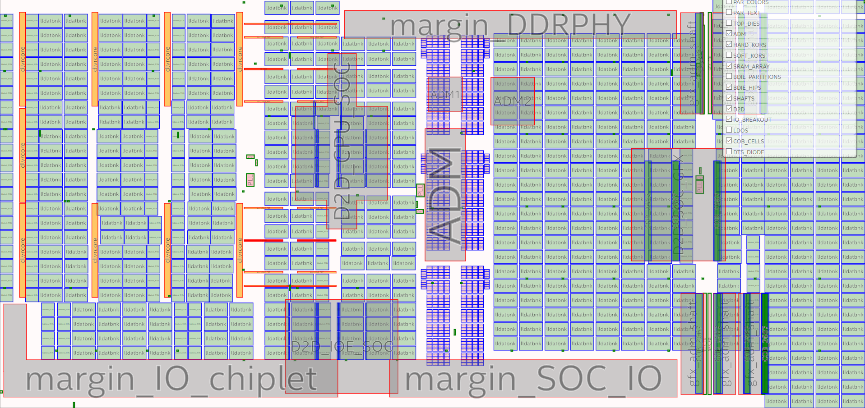
The light grey regions away from the IO and DDR PHY blocks indicates the areas impacted by the D2D and vertical shafts.

Issues
The combination of Foveros + ADM + dis-aggregation led to a challenging co-design due numerous top die constraints, many discovered late in design, resulting in further complexity to work around them. Furthermore, over-subscription of base die resources led to areas of weak power delivery for the base die cache. The issues broadly fall into structural aspects and design process aspects.
Structural aspects
- Power delivery anchors: The areas of dense TSVs anchor the top die and base die together at specific points. The original -- and still main plan -- for power delivery for majority of the top die is a grid of TSVs between rows of ADM datablocks connecting to a grid of top level metals for lateral power delivery to top die micro bumps. This scheme allows the top die to float on the base die without specific anchor points. However, the cores required higher current density in specific location than this TSV grid could deliver.
- Over-subscription of base die resources: Under the top die D2D areas the top level metals of the base die are fully consumed to connect the top die together, preventing use of those top level metals for power delivery for the ADM cache, and blocking access to MIM decap for the ADM datablocks that is located on the opposite side of the top level metals from the ADM datablocks. Similar block out occurred in the vertical shafts. The result is the grey colored areas have weak power delivery resulting in the possibility of excessive voltage droop, and potential data integrity failure.
- Sort test pile-on: the anchors and over-subscription are worsened by the current sort test strategy. The base die is tested at sort by probing the micro bumps. This has 2 ramifications: 1) the base die needs to have a duplicate power delivery network connected to micro bumps – used only for sort test and never thereafter. This worsens the over-subscription with additional routes required through problem areas. 2) the base die micro bumps reserved for sort test project a keep out shadow on the top die, thereby coupling top die design to and base die design.
Design process
- Inadequate resource partitioning & planning up front; realized too late that some changes need to freeze earlier with 3D construction. Hopefully future products can avoid these first time issues.

Learnings
Foveros 3D construction needs advances in two technology areas for tightly coupled logic+memory
- Power delivery -- avoid (or minimize) power delivery going through memory
- Sort test -- avoid additional power delivery construction tax and vertical anchors
In order for 3D logic+memory to become widespread the top die and base die designs need to be further decoupled. In addition to technology approaches, there are also design approaches, such as shifting left on power delivery, and architecting for independence between top and base die. One example of the latter is the MTL thermal management for the base die. Rather than the base die tracking hot spots in the top die – which shift location with design changes – the four MTL top die send the temperature of geographic regions to the base die so the base die has no need to know thermal details of the top die design.
The following table has more details.
Category | Symptom | Diagnosis | Learning/improvement needed/changes
3D construction | Capacity erosion, floorplan churn, fragility, limited re-use | Structural:  Power delivery through memory  Over-subscription of GMs & MIM | Separate power delivery and memory: e.g. top side power, middle interposer  Separate interposer and memory: sufficient resources (private MIM, thick metals) for both  Added backside RDL
3D construction | Capacity erosion, floorplan churn, fragility, limited re-use | Product design:  Insufficient up-front resource planning  Poor GPIO location  Not enough communication | Shift left in future products  Better decoupling of top & base die by design
Power delivery | Droop  Depopulated datablocks | Insufficient connectivity to MIM: GMs & MIM oversubscribed | MIM on datablock side of GM  Shift left on power delivery design  Added traffic shaping to avoid worst cases
Sort test | Depopulated datablocks  Multiple pass test (test time) | Power delivery to micro bumps just for sort  Increased die interdependency | Alternate sort test  Middle interposer?
ADM IP | Droop  Floorplan fit | Insufficient spec allowance for PD; double WL refresh worsened droop  Multiple datablock sizes | PD friendly IP  Added traffic shaping  Added half size datablock
1222 process | Power delivery issues  Large area for D2D | Limited metal stack; MIM optimized for top die  Micro bump pitch & interconnect | Added M9 & M10  Reduce micro bump pitch

PD= power delivery
GM= global memory, i.e. the top level thick metals prized for power delivery
MIM= metal-insulator-metal capacitor
WL= word line
RDL= redistribution layer

Acknowledgements to the TD and LTD ADM teams and the many people in the MTL base die design, floorplan, power delivery, and performance teams that are making ADM and MTL happen. Thank you!

