Title of the invention
Terraced Chiplet Cubing

names of the inventors
Chun-Chiang Kuo (Kuo, CC - WWID 12126211)
Kai-Chiang, Wu (Wu, Max - WWID 12050340)
DerChang Kau (Kau, DerChang – WWID 10077599)

TECHNOLOGY BACKGROUND

Problem Definition - What technical problem did you solve?
Please refer to scheme and illustration below
- In general memory cube stack, each memory tier requires individual vertical bundle of TSVs connecting to base die. Therefore, every memory tier must reserve extra space for other tiers’ channels passing thru, resulting in die size blowing up for TSV area and die cost raising.
- Data transportation of each memory tier use different TSVs group, so each tier must be non-identical and have different RDL layout, resulting in high cost of design, photo masks, and complex process handling. For example, in a real HBM2 consisting of 8 dies stacking, per DRAM die contains >5000 TSVs which occupy extra 12.7% area, and 8 DRAM dies need 8 sets of IPs and photolithography masks. Thus, cost increase a lot, and HBM2 is not scalable for adding more tiers.
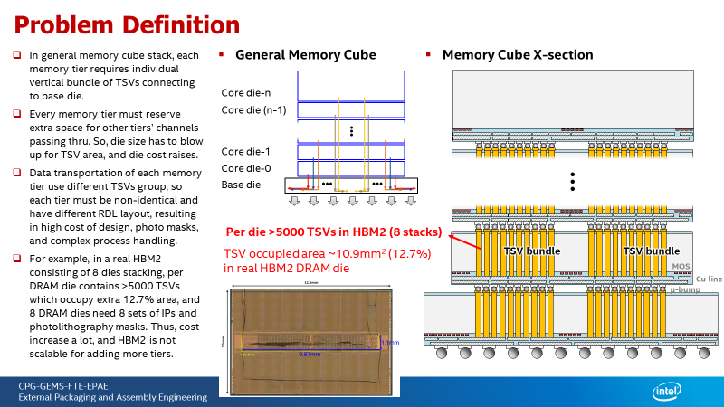

Previous Solutions (if any):

Describe any previous solutions used to solve the problem.
N/A.

Describe disadvantages of those previous solutions.
N/A

OVERVIEW OF THE INVENTION

Short summary – In 1-3 sentences, describe the core of your solution.
Please refer to scheme and illustration below
- Remove TSV bundles in memory die (active die) and replace by an isolated passive die consisting of TSVs only.
- Subsequently, reconnect memory dies to passive TSV die by RDL and u-bump thru advanced package technologies, like fan-out. (To be 1)
- Stack each memory tier with a certain displacement from previous tier to connect to neighbor passive TSV dies. (To be 2)

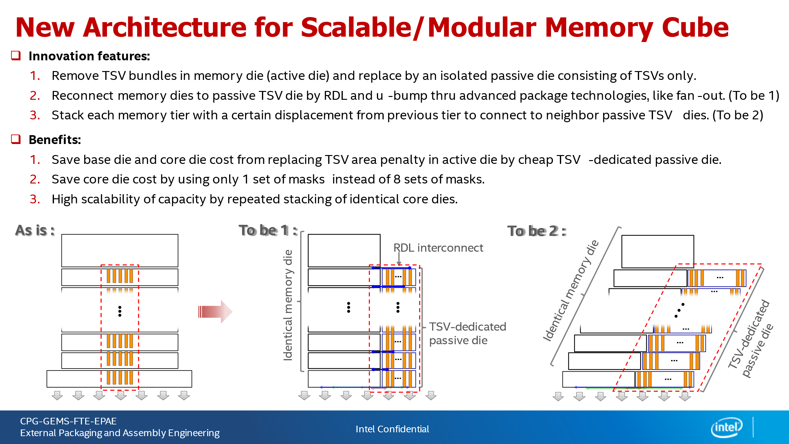

Advantages – In 1-3 sentences, describe the value of the invention to Intel or to our customers.

Terraced chiplet cubing (TCC) is a superior 3DIC technology attributed to the advantages in cost, modularity, reusability and scaling coherence over SOA TSVed or backside Interconnected (BSI’d) 3D stacking.

Displacing TSV from active silicon chiplet with an economical silicon interposer improves active silicon utilization efficiency therefore reduces cost. It improves modularity of chiplet by eliminating the entanglement between TSV and active circuit, eg. Keep-Out-Zoning requirement. It also extends chiplet reusability, for example of adding capacity in the memory cube without redesign of interface circuitry and the associated die to die interconnect. Due to the modularity and reusability, the disclosed methodology enables highly flexible 3DIC integration, for example of a compute subsystem with DRAM, SRAM, logic and mixed signal chips in one stack. Intuitively, it improves scaling cadence coherence cross heterogenous technologies in the stack. Nevertheless, TCC can integrate chiplets with and without TSV/BSI.

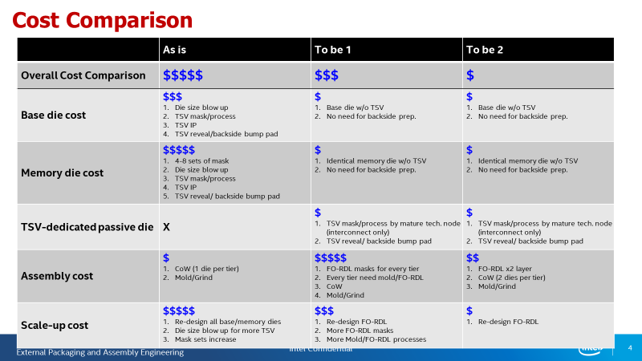

Detectability

Please describe in detail how your invention is detectable in a final product.

If your invention results in a specific structural feature please describe the appearance of that feature (e.g., include SEM/TEMs of actual features if available).
  - Feature: At least 1 TSV-dedicated passive die exists in each tier, and memory die would have no TSV structure inside the chip.

If there are visual inspection and/or reverse engineering techniques that can be used to identify the feature, please describe them.
This feature can be observed by cross-section SEM check or X-ray in a final product.

If documentation such as product literature would show usage of the invention, please let us know what to look for in that regard.
NA

DETAILS OF THE INVENTION

Provide details that help us fully understand your invention, including details on how you solved the technical problem, and at least one figure. You may also provide flowcharts, graphs, slides, or data to support your description. Where appropriate, please provide and explain any empirical support, such as experimental data or simulation results, that can demonstrate the viability of your invention.
Please refer to attached powepoint file.

