Title: Driving a memory hierarchy and technology strategy to win in an increasingly data intensive world
Sponsors: Raja Koduri, Murthy Renduchintala, Navin Shenoy
Whitepaper Contributors: Carolyn Duran, Frank Hady, Jerry Bautista, Mark Pontarelli, Rob Crooke, Rich Uhlig, Pradeep Dubey, Rick Coulson, Randy Osborne, Matt Adiletta
Expected Outcome: A unified One Intel memory technology plan to enable a comprehensive set of executable memory platform strategies.
Strategic Question:
Is compute shifting from being CPU-centric to memory-centric and if so, what is our memory strategy to drive leadership performance? With this shift, how do we build memory and storage hierarchies across our businesses that deliver the critical mass needed to produce memory technologies profitably at scale?
Background & Motivation:
Data sets are increasing in size at a rapid rate. At the same time applications such as AI are accessing these new larger data sets at an increased rate. These competing demands are stressing the memory and storage hierarchy and gaps are appearing. Identifying and filling these gaps, perhaps with the introduction of new technologies to the platform, is a challenge Intel must solve. Application performance is increasingly dependent on our answer as is our competitive position in the marketplace
The gaps induced by the confluence of more data accessed more quickly are evident in the memory and storage hierarchy pictured in Figure 1. To this point, our platforms have come to largely include three levels from this hierarchy: SRAM based and SoC resident Compute caches, DRAM produced by a few suppliers, and NAND based SSDs produced by Intel and others. Selectively across different platforms we’ve seen fit to add to these three layers.
The historical density growth of DRAM, now doubling in capacity every 4 years, lags data growth rates in DC. The cost effects of slowing DRAM capacity scaling combined with accelerating demand for bits leads to significant DRAM BOM growth in a server system. Intel has introduced Optane DC Persistent Memory to provide this higher capacity main memory. In client, DRAM capacity scaling is more aggressive than demand and DRAM minimum capacities are exceeding the needs of client workloads, while DRAM performance scaling is lagging needs. This leads to customer tradeoffs between cost and performance, often to the detriment of the CPU.
An additional layer is emerging between cache and DRAM. In Package Memory (IPM) refers to higher bandwidth per capacity memories packaged with the processor to allow high bandwidth access to data sets too large for SRAM caches, thereby reducing cache misses. IPMs are usually higher bandwidth DRAM variants costing more per gigabyte. High Bandwidth Memory (HBM) is such a technology and Intel is pursuing internal technologies in this space as well.
Lower in the hierarchy, rapid 3D NAND density improvements, including moving to 4 bits per cell (QLC) are doubling density every two years outpacing data growth. As 3D NAND density increases, performance per capacity drops, opening a need for higher performance storage. Optane SSDs are intended to fill this need.
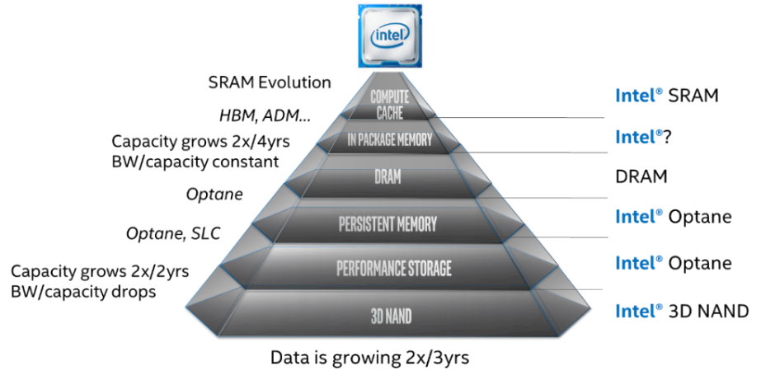
Figure 1. Memory and Storage Hierarchy
The stresses on the memory and storage hierarchy are driving innovations across the hierarchy as well. Moving compute for key kernels across the data center network to storage is one such innovation. Moving computation to memory is another. The increasing relative cost of memory in the platform is changing nature of resource sharing in the hierarchy, with memory pooling potentially disaggregating memory in the data center reducing memory stranding. And cloud-first client continues the move of data storage from the PC to the cloud.
For any one platform the memory and storage hierarchy must present a holistic solution, capable of storing the full data set, persistently, and of making the necessary subset of that data available to the processor at high performance. Obviously, the hierarchies we specify must be rooted in available memory technologies. This means that each platform can’t make independent decisions. Across the set of platforms we create there must be a focused set of memory technologies used, so that each can achieve critical mass for economical manufacture. For those where we choose to rely on others, we need a winning cross company business strategy.
We have challenges across the hierarchy, and competition in nearly every memory technology we play in. Winning solutions must include a framework rooted in software developed in conjunction with the platform choices to optimize for the use cases and conditions of our customers. Software enabling and performance tuning tools must be developed to support our memory strategies. We must holistically solve the hierarchy best to solve our customers hardest challenges and enjoy a significant competitive advantage. With our technologies, software capability, and platform expertise, Intel is uniquely positioned to win here, and we need to get it right.

Key questions and outcomes:
Understanding platform challenges and identifying where Intel can use its IDM advantage to capture value
- How are the relevant application trends, use cases, and KPIs impacting the full memory hierarchy and system architecture in the segments of interest (cloud, edge, client)?
- How do we lead in software solutions for all platforms and hierarchies so that we are a *preferential* solution for our customers and the developer ecosystem?
- How do we solve for bandwidth and capacity in Data Center? Is IPM a necessary part of the solution? If so, which one? Make or buy?
- How do we solve for bandwidth versus capacity in client? Is IPM a necessary part of the solution? If so, which one? Make or buy? How do we align the IPM needs of Client and DC to provided needed memory technology scale?
- What is the right prioritization of Intel’s current memory/compute technologies that maximizes customer benefit and Intel’s IDM business potential?
- Is there a scenario where the architectures of the future shift Intel's future IDM output from 80% logic, 20% memory to 50% memory or more?
- How do we focus efforts to drive volumes on Optane to fill the fab?
- Is there a play in DRAM?
- Where will memories become *smarter*? Do we invest there?
- What internal hurdles to new technology adoption must be removed?
Understanding the ecosystem, identifying and effectively addressing competitive threats
- Can a power/performance/cost 'wall' be used to identify markets ready for a tipping point or about to rapidly expand as a result of innovation in memory and compute architecture?
- What are our competitive threats, and how do we get in front of them?
- What are those ‘black swan’ scenarios where the industry grows but we are left behind due to missed memory innovations?
- Does driving memory innovation necessarily mean competing in the memory market at scale?

