

White Paper
Executive overview of Build-in Selector Memory
Build-in Selector Memory (BiSM)
Potential Future Generation Optane™ Technology: Can we improve Optane media write performance and cost at the same time?

Authors
Al Fazio
Senior Fellow
Erik Hammer
MCM TA

Intel Optane™ Memory Media

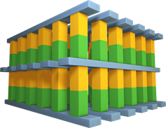
Wordlines
Memory

Selector
Bitlines
Memory

Selector
Wordlines
Figure 1

Executive Summary
The Optane™ memory media array consists of a two terminal cross hatch of wordlines and bitlines, with each memory cell consisting a memory material and a selector material at each intersection. Multiple decking can be processed, increasing the memory density (see Figure 1 with two deck pictorial). The memory cell is written via pulses of current, changing the memory material layer between amorphous and crystalline non-volatile phase, resulting in either a low or high resistance states, thereby storing 0’s and 1’s. In order to uniquely distinguish the resistance of one memory cell from another in the 2-terminal matrix, the selector (a material with diode like electrical characteristics) uniquely selects each memory cell. The amorphous-crystalline non-volatile phase transition requires an energy barrier to be overcome for write, resulting in Write time being ~4X longer than Read time.

During Optane™ memory development, the team discovered the diode turn on voltage of the selector material can be made to “remember” the directionality of the previously applied write pulses. This characteristic offers the potential for the selector material to simultaneously deliver the functionality of both a memory (storing 1’s and 0’s) and a selector (isolating each cell) in the same material layer.

The concept of Build-in Selector Memory (BiSM) removes the memory material layer from the Optane™ structure, using the selector material layer alone, which if proven viable, could potentially bring benefits such as: simplified structure and manufacturing (lower cost) and due to a lower energy barrier of the write mechanism, a much closer symmetry between read and write times (closer to ~1x difference).

Optane™ Memory Media
Optane™ memory media is a bit-addressable structure of rows of wordlines (WL) and bitlines (BL) in a cross-hatch pattern, with each intersection containing multiple stacked cells (figure 2):

PM: Phase Transition Material Layer
Memory element stores information using 2 stable non-volatile states (amorphous and crystalline)
SD: Select Device Material Layer
Selector Device ensures high performance in terms of leakage and single cell selection

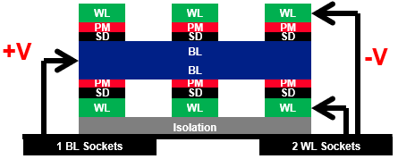

Figure 2

The Polarity Effect
While the PM and SD materials of the Optane™ media are accessed via two terminals and the choice of wordline or bitline is arbitrary, the memory array is always operated in a unidirectional fashion (figure 2). This is done for simplicity of decoder and sensing circuits, where the wordline is always operated at a negative potential relative to the bitlines. By contrast, if we process only the SD material and operate the memory array in a bidirectional manner (meaning we write 1’s with one polarity and write 0’s with the opposite polarity, while always reading with the same polarity), then the diode threshold voltage of the SD can be modulated depending upon the polarity of the write pulse. This provides two memory states.
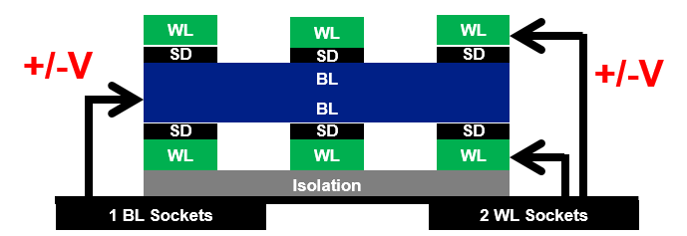

Figure 3

The two-memory states leads to the possibility of a self-select memory of a single material layer that both provides unique cell selection and stores information. In other words, the PM may potentially be eliminated from the Optane™ structure. Additionally, the energy barrier of BiSM write for SD is lower than the phase change energy barrier of PM. This leads to a potential of write time approaching that of the read time, leading to a symmetrical memory.

Key Opportunities

There is potential for process simplification:
- Simplified manufacturing
  - Removes PM related process cost and processing complexity
  - Theoretical potential of 3D-NAND like array architecture (lower cost) vs present lithographically defined array
- Performance Improvement
  - Write latency improvement
  - Elimination of PM reliability constraints.

Key Challenges being studied

We are investigating the physics that are driving the switching mechanism, with initial physical models proposed and in validation. While certain Optane reliability constraints are improved with BiSM, other new mechanisms are introduced. Different material compositions are required for BiSM optimization than is required for the present Optane™ approach. Scalability has not yet been demonstrated.

CMOS Under the Array (CUA) Challenges
Optane™ Memory Media has CUA for each sub-tile. The bidirectional CMOS requirements of BiSM are a key constraint for CUA and ability to match or beat present Optane™ product performance, despite the improved write latency.

Competition

The concept of BiSM was discovered in our JDP with Micron and worked on jointly by both companies. We believe that Micron is pursuing this technology at a priority over the current Optane™ approach.

Conclusion

BiSM is an intriguing opportunity for a future generation Optane™ memory media technology with the benefits of removing a layer in the structure, simplifying manufacturing, and making read/write latency more symmetrical. In other words, it could be similar to Optane, but could be both faster to write and cheaper to manufacture than Optane. Intel pathfinding efforts are underway.

