Contains or Derived from Supplier Confidential Information

Memory and System Integration
Electric Pond (ELP) to influence Nova lake: Congrats on team in reaching RTL 0.5 milestone! Key results include 1) DFT team released RTL 0.5, the first post-DFT release for Electric Pond; 2) Reducing latency (memory die only) from 5.625ns to 4.375ns (by eliminating syncFF flops in datapath (2clk cycles); 3) µbump IO driver layout completed; 4) Updates to bankgroup partition improved timing analysis considerably, reducing # failing paths from 419 to 18 paths. With resources alignment among Q4 test chips activities, DBR target change to WW07’23. 2 cycles access latency reduction is achieved by removing syncFF. Further optimization is needed to close the remaining 2 cycles gap (1.25ns). Access energy assessment is in critical path gating power rail design.

Logic Technology
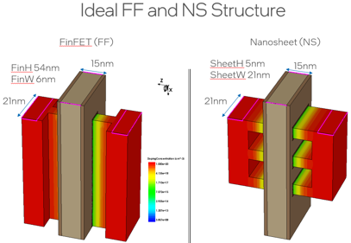
Mock N2 take force is in slow and steady grind with a NanoSheet FEM model developed. Improvements in SS , DIBL, mobility and drive currents from FinFET to NSFET are quantified with TCAD simulations. For example, DIBL improves from 50 to 38.6mV/V in nMOST and from 47.1 to 41.4mV/V for pMOST. These results lend one more level of validity to the Mock N2 device targeting. L2 PPA results with the Mock N3B tech file shows no degradation in power and performance. This validated methodology will be used to generate the tech file for Mock N2 collateral.

ELP Tracking Summary
Next Major Milestone: RTL 0.9 post-DFT RTL, post-verification
Next Major Milestone Target | Current Projection: WW48.5 | WW49.5
DBR Target | Current Projection: WW07'23 | WW07'23
Tapeout Target: WW19'23
Memory Density Target | Current Projection: >2.2 MB/mm² | 2.25 MB/mm²
POR RD/WR Bandwidth Target (2MB) | Current Projection: 102GB/s / 102GB/s | 102GB/s / 102GB/s
POR RD/WR Latency Target (@1600MHz) | Current Projection: 3ns / 3ns | 4.375ns / 2.5ns
Energy per bit Target | Current Projection (TT/85): 0.4pJ/bit | TBD

