The Pursuit of Atomistic Switching and Cross Point Memory
DerChang Kau

Intel Corporation, 2200 Mission College Blvd, Santa Clara, CA, USA
E-mail: DerChang.Kau@intel.com
+V
–V
Figure 2: Memory access in a Cross Point Array

Abstract: With the disclosure of the chalcogenide memory technology in the early 2000s[1], the pursuit of nonvolatile memory beyond electrostatic storage escalated across the industry. Various two-terminal switches exhibiting nonlinear I-V characteristics have been explored as a cost-effect solution. Within a decade, an experimental attempt to integrate chalcogenide switch and memory for a 64Mb array was successfully demonstrated[2]. It illustrated a vision of a new class of memory, bridging the gap between DRAM and SSD. Another decade later, Optane Memory is commercialized, disrupting the prevailing memory hierarchy.
I. Introduction
As illustrated in Figure 1, cost-effective computing architectures construct a layered pyramid of memories, each of which possesses higher performance at lower capacity than the layer beneath. NAND Flash based storage, SSD, has successfully displaced performance deficient hard disk drives as primary storage. However, the gap between main memory (DRAM) and SSD remains significant. Optane memory[3], with high capacity and performance at byte access, is designed to bridge the gap. This paper reviews cross point memory technologies and the enablers for high density, low latency memory.

Figure 1. Layered pyramid of memory – Each layer possesses higher performance & lower capacity than the layer beneath.
II. Atomistic Memory Switching in Cross Point Array
A cross point memory array, as the name suggests, is an array of memory cells sandwiched between orthogonally oriented wordlines (WLs) and bitlines (BLs). As memory switches, the cell alternates between resistance states. Research of memory materials explores atomistic switching mechanisms including spin polarization, ferroelectricity, phase change, interfacial barrier modulation, and filamentation in solid electrolytes or composition segregation. Geometric scalability of atomistic memory is deemed superior to electrostatic memory. For example, the GST scaling limit of the phase change mechanism is experimentally found between 3.6 to 8.8nm[4].
In a cross point memory array, shown in Figure 2, a cell consists of a storage element without a selector device. At standby, all BLs and WLs are 0V biased. When reading a bit, the selected BL goes to +V and the selected WL goes to –V in order to detect the selected bit resistance. However, in a fully networked x-y resistive array, sneak paths through all deselected cells interfere with the intended interrogation. The functionality of cross point array deteriorates as the array size increases. Another issue is the reliability of the array. Since all the deselected bits in the selected WL and BL are biased during memory operation, they are subject to read/write disturb and retention without proper insulation from the bias. Adding a selector in series to each storage element isolates the memory cells, reducing cross talk, improving access accuracy and strengthening reliability.
III. Choice of Two Terminal Selector
In a cross point array, a two-terminal selector must be low resistance when selected in order to access the memory and high resistance when inhibited in order to insulate the memory. Generically speaking, a two terminal selector is a diode exhibiting a nonlinear IV.
A unidirectional diode, such as a PN junction rectifier, can be used for polarity independent memory switching. A rectifying selector turns on one bit with forward bias and isolates others with reverse bias, as shown in Figure 3. During standby, all bits are reverse biased with BLs at 0V and WLs at +V. When one bit is selected, the selected BL switches to +V and selected WL switches to 0V.
Figure 3. A rectifying selector turns on one bit with forward bias and isolates others with reverse bias.
A bidirectional diode, such as a S-shaped DIAC, can be used for both polarity-dependent and ambipolar memory switching. During standby, all bits are zero biased. When one bit is selected, the selected BL switches to +V and selected WL switches to –V. Given that only bits along the selected WL and BL are biased, the bidirectional diode presents a clear advantage in leakage and disturbance.
In the past decade, there were several researches in pursuit of a two-terminal selector[2,5-11] (Table 1). Among those, the Ovonic Threshold Switch (OTS)[12], demonstrated its capability to construct a high density, low latency memory array. 3D XPoint, deployed with OTS, is the only cross point technology that has achieved high-volume production.
Table 1. Pursuing 2-terminal selector for cross point memory
IV. 3D XPoint Technology
The core of 3D XPoint Memory is a two-terminal memory cell, pairing a storage element and an OTS. The storage element is designed such that the entire volume of memory material undergoes bonding transformations between high (fully crystalline) and low (fully amorphous) conductivity with no partial switching for tight statistical control of states (Figure 4).
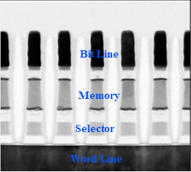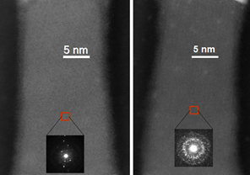
(c)
(b)
(a)
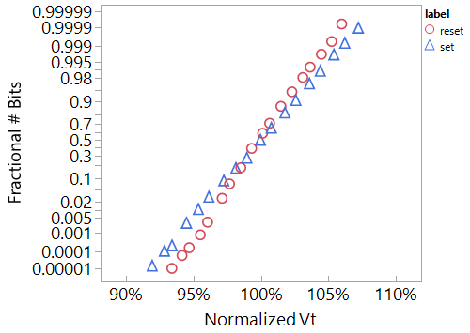
Figure 4: The core of 3D XPoint Memory cell consists of a storage element and an Ovonic Threshold Switch (a). Storage element is fully crystalline (b) or fully amorphous (c) for tight distribution of states (d).
(d)
Cost-effective cross-point memory technology is realized through low thermal budget processes integrated at the cross point between metals. This backend memory technology is compatible with mainstream semiconductor processes that feature CMOS under array allowing deck stacking for low-cost memory products. (Figure 5 and Table 2)

V. Summary
3D XPoint Memory introduces a novel memory cell, consisting of a switch and storage element, to bridge the gap between main memory and storage. The cross point architecture, integrating the Ovonic Threshold switch, a high speed non-volatile storage element, and low RC array parasitics, enables persistent, byte addressable, capacious memory.
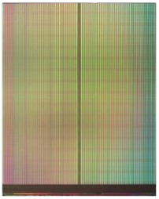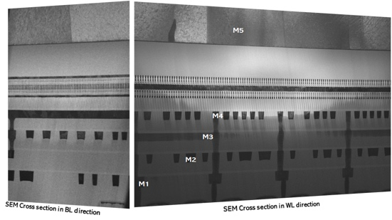
(b)
(a)
Figure 5: First generation 128Gb 3D XPoint Memory (a) featuring 5-level metal CMOS Under Array technology delivers high density, low latency nonvolatile memory.
1st Generation 3D XPoint Media Attributes
Attribute | Value
Cell Feature Size (half pitch) | 20nm
# Decks | 2
Die Capacity | 128 Gbits
Bank Access Size | 16 Bytes
# Independent Banks | 16
Read Latency per Bank | 100nSec
Write Latency per Bank | 500nSec
Write Bandwidth (MB/s) per TB | >35,000MByte/sec/TB
Table 2: Key attributes of 1st generation 3D XPoint media

References:
[1] Stefan Lai, et.al., “OUM - A 180 nm Nonvolatile Memory Cell Element Technology”, IEDM Tech. Dig., 2001, pp36.5.1-36.5.4
[2] DerChang Kau, et.al., “A stackable cross point Phase Change Memory”, IEDM Tech. Dig., 2009, pp27.1.1-27.1.4
[3] 3D XPoint™: A Breakthrough in Non-Volatile Memory Technology, Intel Press Release, July 28, 2015
[4] Simone Raoux, et.al, “﻿Scaling properties of phase change nanostructures and thin films” E*PCOS, 2006
[5] Y. Sasago, et. al., “Cross-point phase change memory with 4F2 cell size driven by poly-Si diode”, VLSI 2009. T2B-1
[6] Z. Wang, et. al., “Threshold Switching of Ag or Cu in Dielectrics”, Adv Func Mtls, Dec/18/2017
[7] B. ﻿Govoreanu, et.al., “Vacancy-Modulated Conductive Oxide Resistive RAM (VMCO-RRAM)”, IEDM 2013. S10.2
[8] K. Gopalakrishnan, et. al., “Highly-Scalable Novel Access Device based on MIEC Materials for High Density Phase Change Memory (PCM) Arrays”, VLSI 2010. TS19.4
[9] S.G. Kim, et. al., “Improvement of Characteristics of NbO2 Selector and Full Integration of 4FF2 2x-nm tech 1S1R ReRAM”, IEDM 2015. S10.3
[11] S. Yasuda, et. al., “A Cross Point Cu-ReRAM with a Novel OTS Selector for Storage Class Memory”, IEEE VLSI, 2017
[10] T. Kim, et. al., “High-performance, cost-effective 2znm two-deck cross-point memory”, IEEE IEDM, 2018
[12] D. Adler, et. al., "The mechanism of threshold switching in amorphous alloys", Review of Modern Physics, Vol. 50, No.2, 1978

