Advanced Technology and Systems of Cross Point Memory

Albert Fazio

Intel Corp. Santa Clara, CA, USA
2200 Mission College Blvd, Santa Clara, CA 95054, USA
Tel:408-765-9610 Email:Al.Fazio@intel.com

Abstract
Cross point memories are ideally suited to fill computer memory hierarchy gaps of memory capacity and storage performance. System innovations exploiting the capability of 3D XPoint challenge historical notions of separate semantics of memory and storage, significantly boosting performance.

Introduction
A decade ago, NAND SSDs began to fill the large performance gap that had emerged between DRAM and HHDs in mainstream computing memory hierarchy. Today, SSDs are fundamental to the memory hierarchy of a modern computing system. In the intervening time period, DRAM scaling has slowed (fig. 1) and performance growth of NAND has not kept up with its capacity growth (fig. 2). Coupled with significant increases in CPU core count demanding increased memory bandwidth, and higher speed CPU links and networks, two gaps have widened in computing memory hierarchy: A load/store memory capacity gap and a storage performance gap. The commercialization of 3D XPoint [1] cross point memory with high capacity, low latency, and byte write capability is demonstrating suitability to fill this gap. New computing system architecture innovations exploiting 3D XPoint memories are altering the notion of separate worlds between memory and storage semantics, significantly improving system performance. This paper reviews 3D XPoint memory technology, how it is appearing in computing systems, and discusses future directions.

Cross Point Memories
The industry has been researching 3D cross point memories [2-6] to simultaneously meet favorable performance and cell size characteristics and therefore a higher likelihood of widespread acceptance. The challenges in realization has been the memory material system of choice and the limited options for thin film selectors with appropriate Ion/Ioff characteristics. Memory systems of metal oxides relying on oxygen vacancies [7], or electrochemical cells [8] are relatively easy to process, but subject to filamentary stochastic variation [9]. Choosing of memory element material systems capable of bulk switching, has been key for realizing successful technology commercialization. Adding to the challenge, with few good thin film selectors choices, successful commercialization relies on mating electrical and chemical behavior of memory and selector.

3D XPoint Technology
3D XPoint is the only cross point technology, to date, having achieved successful and substantial high-volume production. It is discussed here as an example of cross point technology. 3D XPoint traces multiple genealogical paths, while creating capabilities not found in the origins. Thus, 3D XPoint is an entirely new class of memory technology.

3D XPoint consists of three key technological elements: 3D layered memory in backend metalization, with CMOS under the array; a combined thin film selector and memory structure; and atomistic storage in the memory layer (fig. 3, 4). Each memory layer is formed with solely two lithography steps and subtractive etching, facilitating process simplicity and low cost. Wordlines and bitlines are formed in low resistivity conductors, enabling low RC required for low latency memory applications. A two-terminal amorphous alloy ovonic threshold switch is deployed as the selector of the memory cell. Symmetrical blocking or triggering voltage (threshold voltage) of the amorphous alloy [10] provides for robust inhibiting to isolate individual memory cells in the cross point array and large sub-array tiles for low cost.

3D XPoint memory element is based upon chalcogenide alloys. Unlike phase change memory [11], which also shares a chalcogenide genealogy, 3D XPoint does not rely on any sub-lithographic interfacial heating/switching structures, such as mushroom, µ-tench, pore, cross spacer, or ring shapes [12-16]. Additionally, in departure from chalcogenide shared genealogy, the entire bulk of the memory material of 3D XPoint undergoes bonding transformation between high and low conductivity states with bits in either fully amorphous state and fully single crystalline state, and no partial dome switching (fig. 5), ensuring tight statistical control of states. In a phase change memory, the set operation follows a classic stochastics crystallization growth process initiated at amorphous crystalline interface [17,18]. However, due to the entirety of atomistic transformation in the bulk of memory element, the interface of such phases does not exist in 3D XPoint technology. In addition, 3D XPoint technology exploits deterministic write algorithms; no program verification is required. Carbon electrodes provide diffusion barrier between active layers and cell process integration for efficient and reliable read/write operations. These fundamental architectural advantages enable low latency, low energy, high bandwidth and high endurance non-volatile memory subsystem for persistent memory applications.

First generation 3D XPoint is 20nm half pitch with two decks of memory per 128Gbit die. The product consists of 8K tiles, each tile a 2K worldine x 4K bitline x 2 deck cross point array (fig. 6). Each tile selects a single bit for read or write with direct write capability. The cross point architecture and low latency materials and interconnects enables 3D XPoint attributes shown in Table 1 of high capacity, low latency, direct write, and non-volatility. Density per die are significantly larger than DRAM; more comparable to NAND. Access size of 16 Bytes per bank and multi independent read/write banks per chip, enables memory compatible cache line load/store operation and efficient die to configure into low latency high performant memory-storage systems. Read and Write latencies are asymmetric, like other non-volatile memories requiring an energy barrier to be overcome, with both orders of magnitude faster than NAND approaching DRAM latencies, providing for high performance.

System Level View of Cross Point Technology
Optane™ SSDs [19] and Optane™ Data Center Persistent Memory Modules [20] are described to illustrate how capabilities of 3D XPoint are exploited to fill the load/store memory capacity gap and storage performance gap in mainstream computing (fig. 7). The unique attributes of 3D XPoint in Table 1 enable the creation of new classes of computing subsystems. Optane™ SSDs deliver performance per capacity, latency, and responsiveness under load not available with NAND SSDs. Intel Optane™ Data Center Persistent Memory (PMEM) introduces an entirely new form of memory to computing, addressable like DRAM, but with larger capacities and persistence through power removal. Much like the memory on which they are built, these new devices blur the line between memory and storage.

Optane™ SSDs make 3D XPoint media available as Operating System managed storage connected physically as standard PCIe/NVMe SSD. Optane SSDs are architected specifically to deliver the value of 3D XPoint. The SSD controller features a hardware only read/write path and spreads each 4kB data unit (1 or 8 sectors) across multiple 3D XPoint die and across multiple banks within a die allowing reads to be returned in approximately 8 microseconds (idle latency). 3D XPoint direct write capability allows writes to complete quickly, in-place (no block erase), and at the native size of the operation (in multiples of 4kBytes) eliminating the need for garbage collection and enabling a highly truncated latency tail. Latencies are more than an order of magnitude better than NAND based SSDs (fig. 8). Finally, with much higher endurance media and no write amplification, Optane SSDs deliver endurance much greater than NAND SSDs.

With low latency, excellent quality of service, and high endurance, Optane SSDs are employed in systems where performance is critical. When used as data caches, or as a data tier, Optane SSDs also absorb writes, enabling the NAND SSDs holding the bulk data to save on cost. Finally, Optane SSDs enable fast paging systems, extending main memory in a way NAND SSDs cannot.

Optane™ Persistent Memory makes 3D XPoint visible as system memory, providing the long dreamt of persistent, byte addressable, capacious memory. Connected as system memory with the low latency cache coherent processor interconnects, these modules contain a custom controller featuring a low latency hardware read/write path to multiple 3D XPoint die and provide an average idle latency of just 340ns (fig. 9). First generation PMEM with capacities up to 512GB per module, more than double the maximum density of current DRAM DIMMs, enable 4.5TB per CPU socket. At the system level, Optan PMEM can be managed either as a memory cached in DRAM, or as a persistent memory in its own address space distinct from DRAM. Optane PMEM is the subject of intensive experimentation and development by many software developers. As a very large memory it enables more VMs to be hosted per physical CPU, avoiding time consuming swapping of state in and out of storage. As large persistent memory it enables very large databases to be held in memory and to be used immediately at bootup without time consuming storage load times.

Computing systems are evolving to new topologies with Optane PMEM. Distributed Asynchronous Object Store (DAOS) is optimized for Object Store with Optane PMEM [21]. In DAOS, the metadata storage pool (Metadata, low-latency I/Os & indexing/query) are held in Optane PMEM and bulk data object store is held in NVMe SSD’s (either NAND or Optane SSD) and is demonstrating significant performance increases over non-PMEM storage systems [22]. In Oracle Exadata, the storage file system is bypassed by Direct Memory Access to persistent memory on the storage server, demonstrating significant performance increases [23].
Future Cross Point Technology and System Directions
3D XPoint is at the beginning of its scaling journey, in both capacity and performance. 2nd generation 3D XPoint increases number of decks from two to four (fig. 10), while increasing bank count by 2x, improving bandwidth. Lateral scaling and deck scaling will continue to increase capacity, decreasing cost per bit. Material tuning and circuit design optimization will decrease latencies and increase bandwidth. The system innovations with PMEM noted above are a sign of a truly disruptive technology success: when the technology begets new architectures and new solutions, as we are seeing in the industry. 3D XPoint cost and performance scaling capability ensures new system innovations as just beginning.

Conclusions
Cross point memory, as demonstrated through 3D XPoint and Optane™ SSDs and Persistent Memory Modules are proving ideal at filling the memory capacity and storage performance gaps. Future scaling of cross point memory coupled with system innovations exploiting the capability of 3D XPoint emerging in the industry, promise to challenge the historical notion of separate worlds between memory and storage semantics, significantly increasing system performance.

References:
[1] 3D XPoint™: A Breakthrough in Non-Volatile Memory Technology, viewed 17 August 2020, https://www.intel.com/content/www/us/en/architecture-and-technology/intel-micron-3d-xpoint-webcast.html?language=en_US&wapkw=3D%20XPoint
[2] M. Lee, et. al., IEEE IEDM, 2007
[3] D. Kau, et. al. IEEE IEDM, 2009
[4] Taehoon Kim at.al, IEEE IEDM 2018
[5] H. Y. Cheng, et.al, IEEE VLSI 2020
[6] S. Kabuyanagi, et.al, IEEE VLSI 2020
[7] Taehoon Kim, et.al, IEEE VLSI 2018
[8] Shuichiro Yasuda et. al, IEEE VLSI 2017
[9] S. Ambrogio et. al, IEEE IEDM 2013
[10] David Adler, Heinz K. Henisch and Sir Nevill Mott, "The mechanism of threshold switching in amorphous alloys", Review of Modern Physics, Vol. 50, No.2 pp.209-220, 1978.
[11] H.-S. Philip Wong, at. al. Vol. 98, No. 12, December 2010 Proceedings of the IEEE
[12] Y.H Ha, et. al., IEEE VLSI 2003
[13] F. Pellizzer, et. al., IEEE VLSI 2004
[14] M. Breitwisch, et. al. IEEE VLSI 2007
[15] W.S. Chen, et. al. IEEE IEDM 2007
[16] J.H. Oh, et. al. IEEE IEDM 2006
[17] T. Nirschl, et. al. IEEE IEDM 2007
[18] A. Sebastian, et. al. “Crystal growth within a phase change memory cell”, Nature Communications, 7 July 2014, DOI: 10.1038/ncomms5314
[19] Hady, et. al., “Platform Storage Performance With 3D XPoint Technology”, Proceedings of the IEEE Vol. 105, No. 9, September 2017
[20] J. Izraelevitz, et. al., “Basic Performance Measurements of the Intel Optane DC Persistent Memory Module”, arXiv:1903.05714 [cs.DC]
[21] Z. Liang, et. Al. “DAOS: A Scale-Out High Performance Storage
Stack for Storage Class Memory” Supercomputing Frontiers 6th Asian Conference, SCFA 2020, Singapore, February 24–27, 2020, Proceedings
[22] Virtual Institute for I/O, viewed 17 August 2020, https://www.vi4io.org/io500/start
[23] Exadata X8M | Persistent Memory (PMEM) Explained, viewed 17 August 2020, https://www.youtube.com/watch?v=jMAoc1b7VMw

Gen-1 3D XPoint
Attribute | Value
Cell Feature Size | 20nm
# Decks | 2
Bank Access Size | 16 Bytes
# Independent Banks | 16
Read Latency per Bank | 100nSec
Write Latency per Bank | 500nSec

Table 1: Key Attributes of 3D Xpoint Product

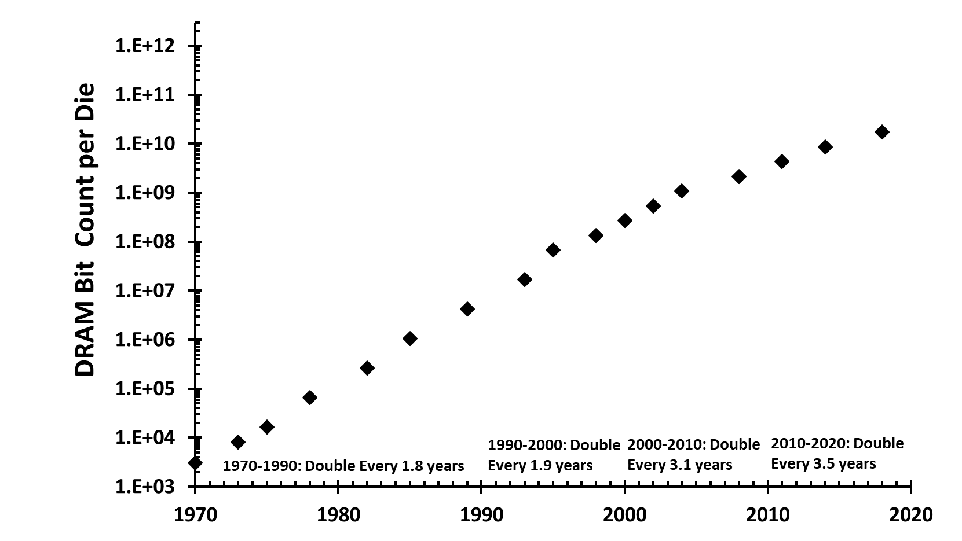

Figure 1: DRAM Scaling over past 5 decades. Prior to 2000, DRAM scaling progressed at rate of doubling density in less than 2 years. Post 2000, DRAM scaling has slowed with rate in last decade of doubling every 3.5 years.
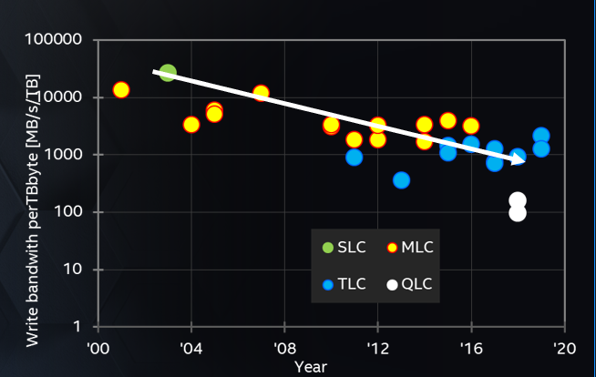

Figure 2: While capacity has grown for 3D NAND, performance – write performance in particular – has not kept up with capacity growth.

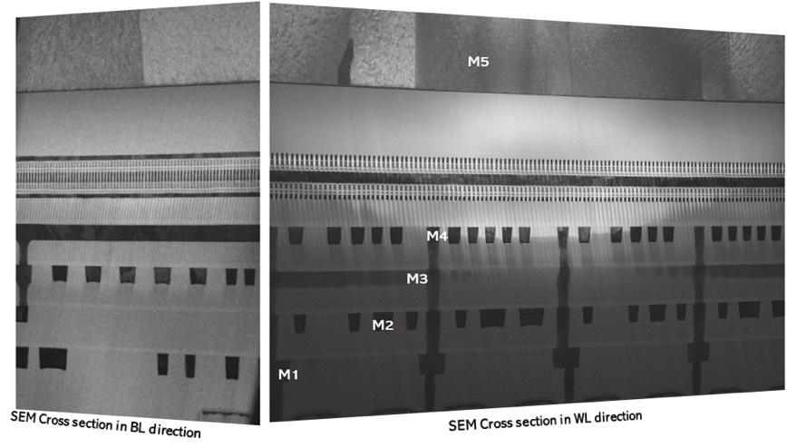

Figure 3: 2-deck 3D Xpoint tight pitch array residing above 4-level metal CMOS
BL
WL
RESET
SET

Figure 4: Single Deck Cell Cross-Section, with Wordline (WL) and Bitline (BL) noted. Dark regions within the cell are selector and memory materials, separated by carbon electrodes.
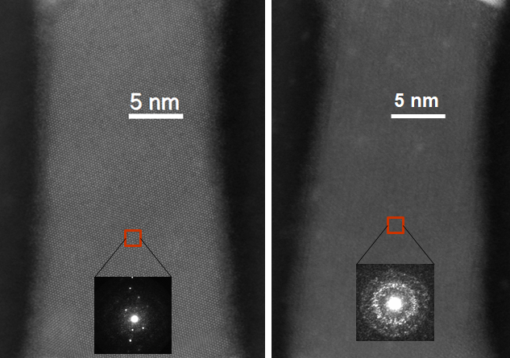

Figure 5: TEM Cross Section showing entire cell in fully crystalline and fully amorphous bits in SET, RESET states

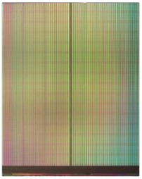










Figure 6: Die photo of 128Gbit 3D XPoint

Figure 7: Memory Heirarchy with OptaneTM SSD filling the Storage Performance gap and OptaneTM PMEM filling the Memory Capacity gap

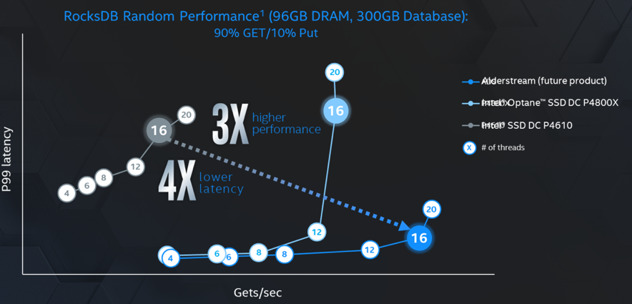

Figure 8: Optane vs NAND Latency Tails – check with Frank if correct graph – get original data and re-graph

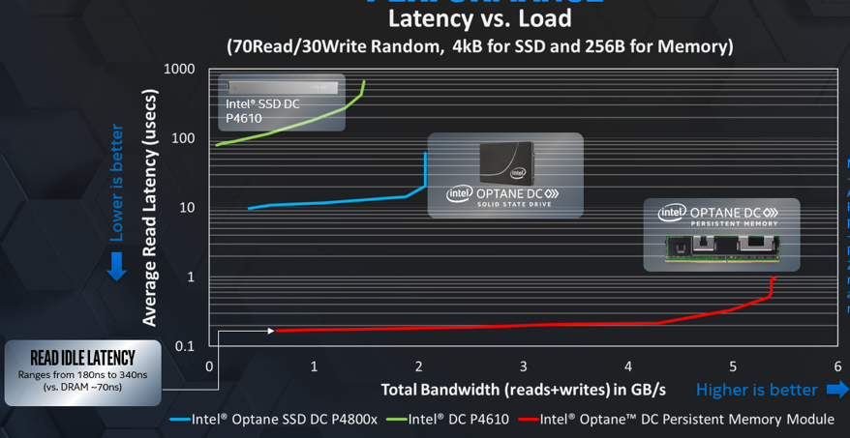

Figure 9: Latency at load of NAND SSD vs Optane SSD with 3D XPoint vs Optane PMEM with 3D XPoint

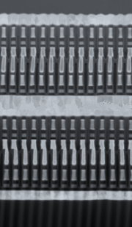

Figure 10: Cross Section of 2nd generation 3D XPoint with 4-Deck Array

