Instructions
- Do not remove this page. The Brevetto Web application will reject this document if this page is removed.
- You must enable macros so the embedded checkboxes and radio buttons are enabled.
- Fill in your invention description on the following pages. It is important to provide accurate and detailed information and that you answer ALL of the questions. This information will be appended to the questions answered online and will be used to evaluate your invention for potential filing as a patent application.
- Review this document with your co-inventors.
- Once complete, edit your Disclosure in the Brevetto Web application. Use the “Upload IDF Document” button on the “Upload IDF Document” tab to upload this document to your disclosure. You may upload revisions of this document prior to submitting it for approval to enable your co-inventors to view the document online while it is still being edited. Uploading revisions will overwrite what is currently on file in Brevetto.
- To ensure complete functionality of the template in Microsoft Word, make sure to use Word 2010 and save the file locally in the Word Document (*.docx) file format.

PLEASE NOTE: Contact the TAC for any issues relating to the Brevetto application by phone (e.g. your local prefix +-1234, choose language then option 1, 3, 4, 2) OR online at http://it.intel.com/. Click on Software then select Brevetto under the Legal Apps menu.
Click [Submit/View a Request]
Category="Application Software"
Sub-Category="L",
Item="Legal - Brevetto"
ATTENTION
All inventors MUST complete questions A – D below. If any inventor is employed by one of Intel’s European legal entities in Germany, Austria, Denmark, or France, each inventor MUST also answer questions E – H.

1st. inventor |  | 2nd. inventor |  | 3rd. inventor | 4th. inventor
- Name (Last, First):
Kau, DerChang
- Personnel number (Intel WWID, if Intel employee)
10077599
- What percentage share of the invention at the time of submission do you hold? Please specify whole numbers only and the total for all inventors must add up to 100%. If not specified below, the default is an equal percentage share for all inventors.
100 % |  | % |  | % | %
- In what country did you reside when the invention was created?
USA
- At the time of the invention: Were you on a long- or short-term assignment to another legal entity?
- Occupation / Position / Title within the company: (e.g. design engineer)
Engineering/Director/Intel Fellow
- Was the invention developed in  (select one only) | a. your direct work field?  b. different field of work at your employer?  c. other area which does not relate to your employer?
- Was the invention developed in response to a request from your employer to solve a particular problem?

5th. inventor |  | 6th. inventor |  | 7th. inventor | 8th. inventor
- Name (Last, First):
- Personnel number (Intel WWID, if Intel employee)
- What percentage share of the invention at the time of submission do you hold? Please specify whole numbers only and the total for all inventors must add up to 100%. If not specified below, the default is an equal percentage share for all inventors.
% |  | % |  | % | %
- In what country did you reside when the invention was created?
- At the time of the invention: Were you on a long- or short-term assignment to another legal entity?
- Occupation / Position / Title within the company: (e.g. design engineer)
- Was the invention developed in  (select one only) | a. your direct work field?  b. different field of work at your employer?  c. other area which does not relate to your employer?
- Was the invention developed in response to a request from your employer to solve a particular problem?

9th. inventor |  | 10th. inventor |  | 11th. inventor | 12th. inventor
- Name (Last, First):
- Personnel number (Intel WWID, if Intel employee)
- What percentage share of the invention at the time of submission do you hold? Please specify whole numbers only and the total for all inventors must add up to 100%. If not specified below, the default is an equal percentage share for all inventors.
% |  | % |  | % | %
- In what country did you reside when the invention was created?
- At the time of the invention: Were you on a long- or short-term assignment to another legal entity?
- Occupation / Position / Title within the company: (e.g. design engineer)
- Was the invention developed in  (select one only) | a. your direct work field?  b. different field of work at your employer?  c. other area which does not relate to your employer?
- Was the invention developed in response to a request from your employer to solve a particular problem?

Please provide a description of the invention and include the following information:
- Describe your invention:
What problem(s) does your invention solve? Briefly describe the problem you are addressing and previous solution(s), if any:
Current Art: The state of art of embedded non-volatile memory technologies include Flash, STTM, PCM or various mechanisms of Resistive Change memory. The memory cells are implemented in configurations of 1-Transitor-1-Memory (1T1M) or 1-Selector-1-Memory (1S1M). Transistor can be a bipolar junction transistor or a field effect transistor. Selector is typically a two terminal diode such as PN junction diode.

Problem: The challenge to the current art is the scalability of physical footprint and/or energy efficiency.

Solution: One memory unit contains one or multiple 3D XPoint™ cells wired-OR connected to one transistor.

- Your Idea – Provide a high-level summary of your idea that includes a figure or flowchart. Be sure to note differences between your idea and the previous solutions and to note what advantages your idea provides. Please break down the high-level summary of your idea into 3 portions as indicated by the 3 questions 2a, 2b, and 2c below:
- What is the basic principle? Please explain in just a few sentences (do not provide results or use cases here).
To read and write a memory cell in a memory array, the memory cell is addressable by turning on one array transistor of a memory unit and one bitline. All other bits are inhibited by either turning off array transistor or bitline bias.

- How is your invention better than the known solutions (answer can include results, applications, or use cases)?
- Energy consumption: 3D XPoint enables lower programming current (than PCM).
- Cost: Cross Point technology inherently possess high density for cost advantage. Multiple wired-OR 3D XPoint to a single transistor amortizes the silicon-footprint of array transistor.
- Performance: 3D XPoint array demonstrates near DRAM performance with good NVM reliability. The word-addressable array architecture fulfills a critical need of high performance, random access embedded NVM in on-chip memory hierarch.
- Moore’s Law: 3D XPoint is the leading non-volatile memory technology in atomistic switching. The underline physics warrant it’s scalability beyond the technology based on electrostatic switching.

- Provide a more detailed description of your invention, highlighting what is new (please include block diagrams, process flow diagrams, etc., and limit the text to no more than 3 pages).
Current Art: One-Transistor-One-Resistor Memory (1T1M or 1T1R):
- Memory Cell –
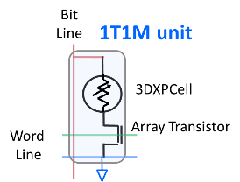
- Memory Array –
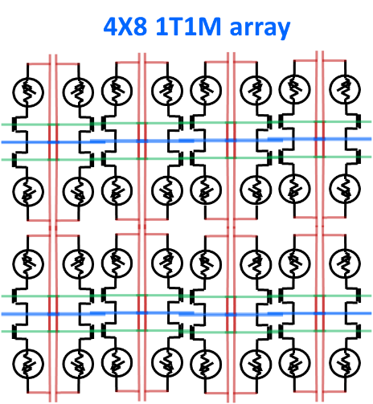

This invention:
- One-Transistor-One-3DXP-Cell (1T1C)
Memory Unit –
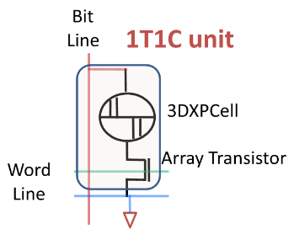
Memory Array –
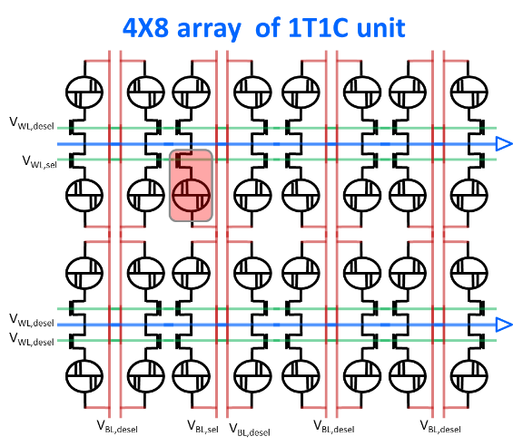
Memory access in Array –
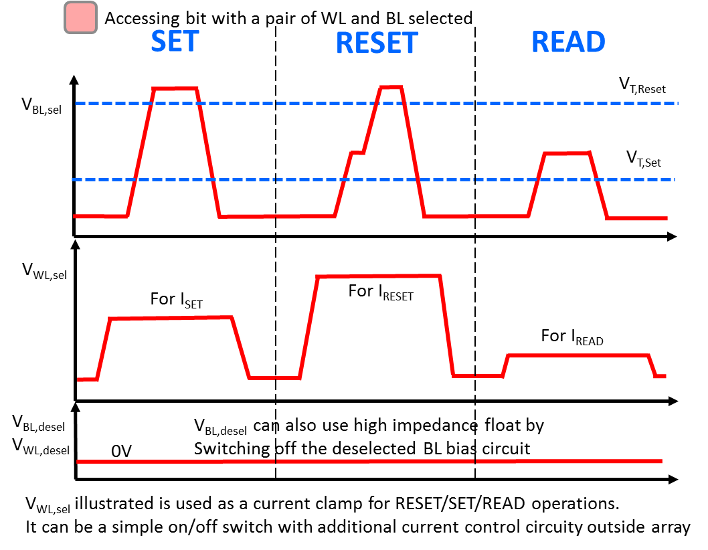
- One-Transistor-mulitiple-3DXP-Cell (1TmC)
Memory Unit –
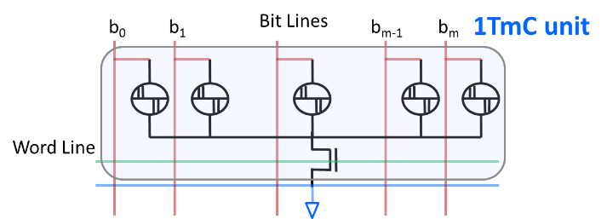
Memory Array –
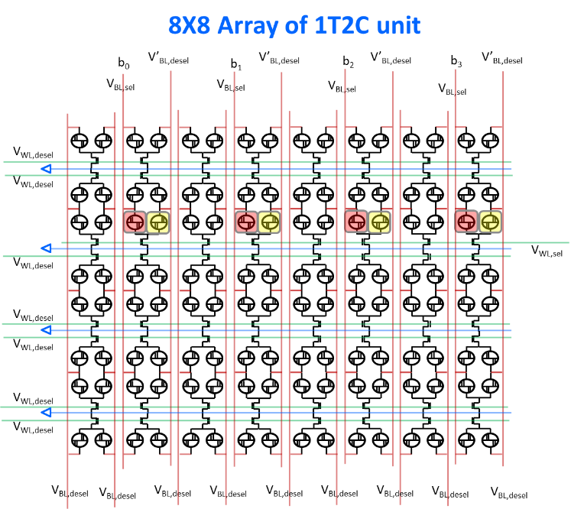
Memory access in Array – similar to the array of 1T1C unit.
: Parallelism: accessing bits with 1 WL and 2 or more BLs selected (4 BL selected in the exhibit)
: The deselected bits of selected unit, sharing the same Array transistor (1T) of the accessed bits. The deselect bitline bias, V’_{BL,desel}, can be either 0V or high impedance float.
eNVM Subsystem --
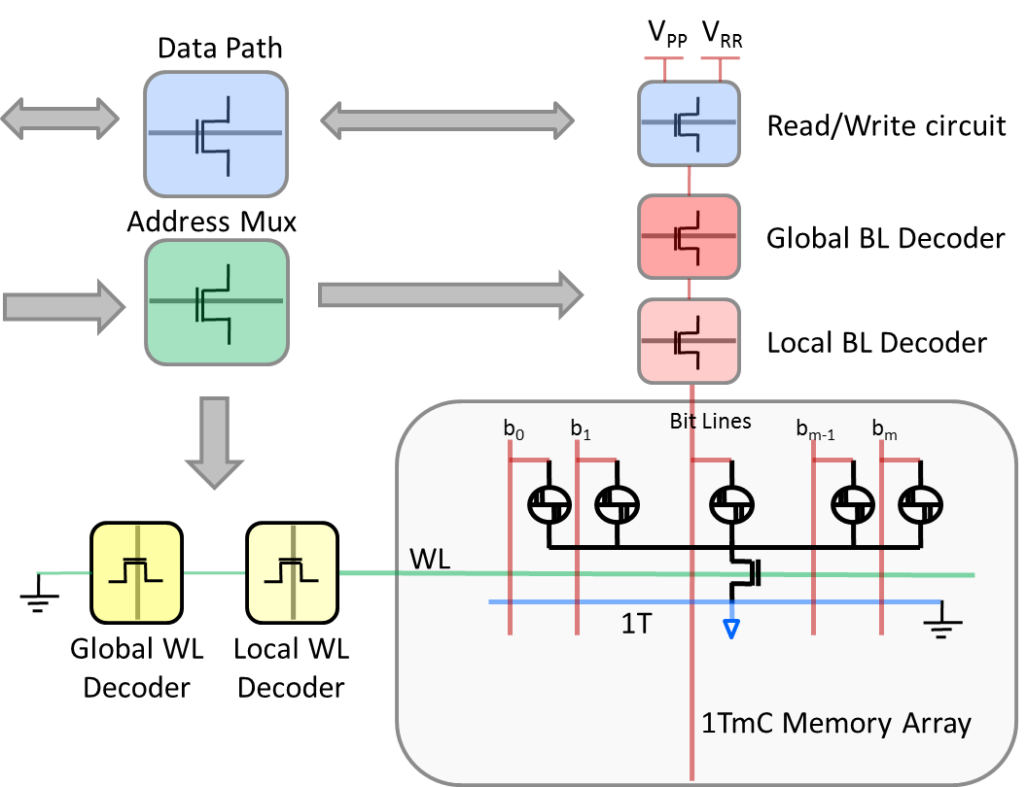

- Which of our competitors are likely to use your idea or something similar?
Samsung, TSMC or Global Foundry.

- How would we be able to determine if someone outside of Intel was using your idea (e.g. from visual inspection, from the product literature, from reverse engineering)?
Product literature and reverse engineering

- Is this idea related to work performed in a Standard Development Organization (SDO) or Special Interest Group (SIG)?

If YES, please answer the following (a, b, c):
- Identify the SDO or SIG involved:

- Is this IDF prepared in anticipation of being part of an Intel proposal or submission for this SDO/SIG?

If YES:
- Identify the date of first disclosure to a party outside of Intel and outside of a confidentiality agreement (actual or anticipated):

- Provide the name of the person(s) driving Intel’s efforts for this SDO/SIG that have been made aware of this idea, if any:

- Is there an implementation of this idea which might not be covered by a standard requirement?

- To the best of your knowledge, identify any other pertinent information related to your idea.

- Describe any aspects of your idea relating to unusual results or unusual function of the components/techniques in the idea, or check the box below:
The unique combination of components/techniques in this idea provides an improvement over previously known structures and techniques:

- What is the value of your idea to Intel (how will it be used by Intel or a competitor)?
A candidate of eNVM subsystem for logic technology such as P1222.

